**Project Design Phase-II**

**Technology Stack (Architecture & Stack)**

|  |  |
| --- | --- |
| Date | 03 October 2022 |
| Team ID | PNT2022TMID10029 |
| Project Name | Project – AI-based localization and classification of Skin Disease using Erythma |
| Maximum Marks | 4 Marks |

**Technical Architecture:**

The Deliverable shall include the architectural diagram as below and the information as per the table1 & table 2

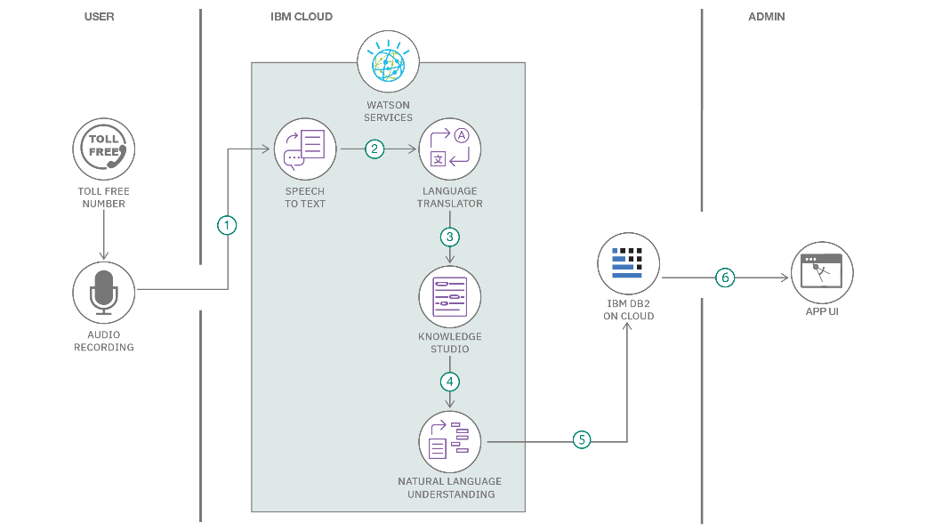

**Table-1 : Components & Technologies:**

|  |  |  |  |
| --- | --- | --- | --- |
| **S.No** | **Component** | **Description** | **Technology** |
|  | User Interface | How the user interacts with the application e.g.  Web UI, Mobile App, Chatbot, etc. | HTML, CSS, JavaScript / Angular Js / React Js, etc. |
|  | Application Logic-1 | The logic for a process in the application | Python |
|  | Application Logic-2 | The camera captures and extracts the image and analyze the result | IBM Cloudant DB |
|  | Application Logic-3 | Extract the Report | Annotate images using Microsoft's Visual Object Tagging Tool (VoTT). |
|  | Application Logic-4 | Conversion of captured video as Report | YOLO Model |
|  | File Storage | File storage requirements | Local Filesystem |
|  | Machine Learning Model | Purpose of Machine Learning Model | URL detection classification Model. |
|  | Infrastructure (Server / Cloud) | Application Deployment on Local System / Cloud | Local, IBM Cloud  . |

**Table-2: Application Characteristics:**

| **S.No** | **Characteristics** | **Description** | **Technology** |
| --- | --- | --- | --- |
|  | Open-Source Frameworks | * Microsoft's Visual Object Tagging Tool (VoTT). * YOLO Model | Preprocessed image or video frame is detected and trained to predict the output using the YOLO Model |
|  | Scalable Architecture | * Convolutional neural network (CNN) can be scaled in three dimensions: depth, width, and resolution. * The depth of the network correlates with the number of layers present within. * Width is associated with the number of neurons in a layer. * Resolution is the image resolution that is being passed to CNN. Increasing the depth, by stacking more | Convolution Neural Network (CNN) |
|  | Availability | Preprocessed Image or video frames are trained by YOLO Models and the model will be sent to UI they get trained to predict the output with the help of IBM Cloudant DB and detects the Disease | YOLO Model  UI  IBM Cloudant DB |